Anthony Redamonti

Syracuse university

Homework 2

CIS-623 structured programming & formal methods

prof. Mehmet kaya

1/20/2022

For each of the following set of formulas, show if there is an entailment relation from formulas in a to the formulas in b. Give a formal proof if the entailment relation holds from the formulas in a to b.

Question 1:

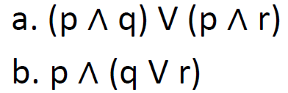

Yes, there exists an entailment relation from formula a to formula b. The proof is in the picture below.

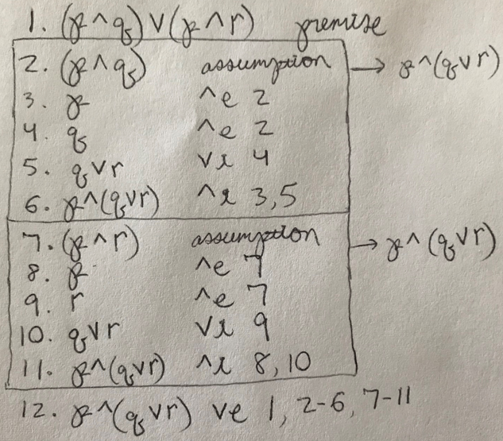

Question 2:

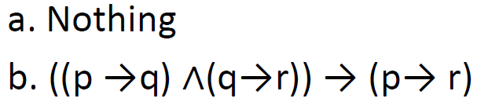

Because formula a is “Nothing” we will check the validity of formula b.

Yes, formula b is valid. The proof is in the picture below.

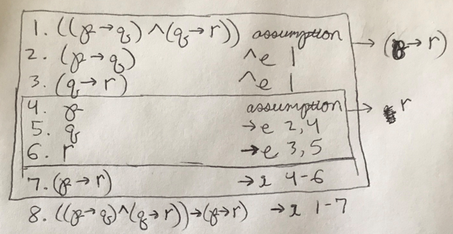

Question 3:

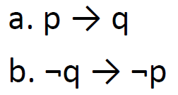

Yes, there exists an entailment relation from formula a to formula b. The proof is in the picture below.

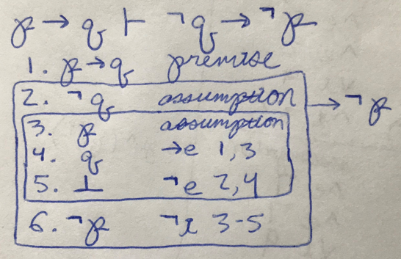

Question 4:

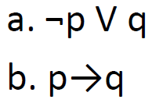

Yes, there exists an entailment relation from formula a to formula b. The proof is in the picture below.

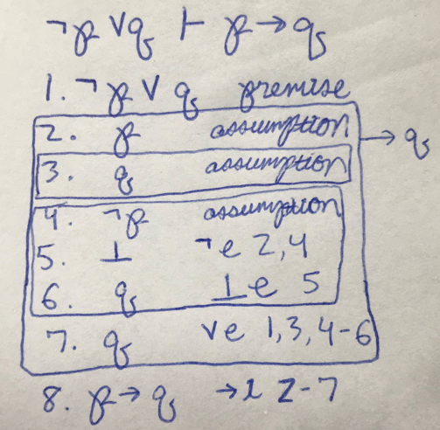

Question 5:

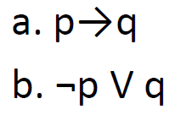

Yes, there exists an entailment relation from formula a to formula b. The proof is in the picture below.

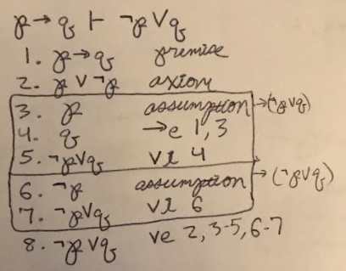

Question 6:

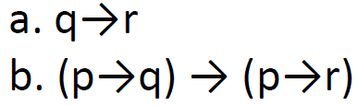

Yes, there exists an entailment relation from formula a to formula b. The proof is in the picture below.

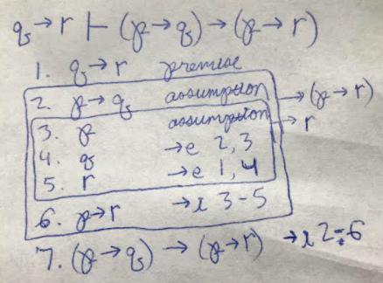

Question 7:

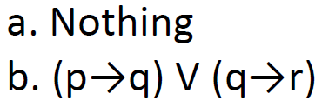

Because formula a is “Nothing” we will check the validity of formula b.

Yes, formula b is valid. The proof is in the picture below.

